Shift Statement. It allows you to move the contents of a character string left or right, character by character.

So as an example, let' see how we can move the contents of a field to the left, deleting leading zeros.

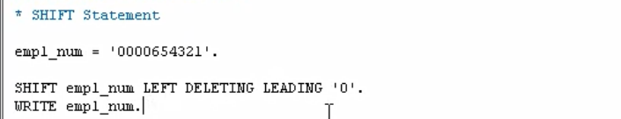

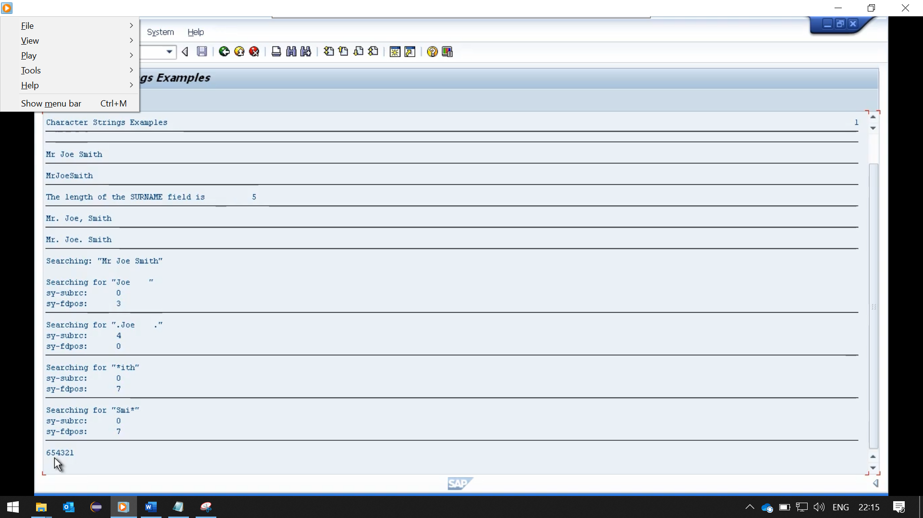

So first, I'll declare a new variable. Let's call this one employee num, for employee number. We'll make it 10 characters in length.

And the first thing we'll do, we'll set the contents of this field to, so we'll fill in every character of the field. And what we're going to do with the example is remove the leading zeros. And shift everything else to the left-hand side. So, to do this we just type the statement shift. And our field name it will define we want to shift the contents to the left. Whilst deleting the leading zeroes.

Now before we run this, I'll bring up the search help for the shift statements. And you'll see there are various variants showing that you can shift to the left, to the right, by a specific number of places and so on.



Here you can see the actual output has deleted the leading zeros and moved everything to the left-hand side.

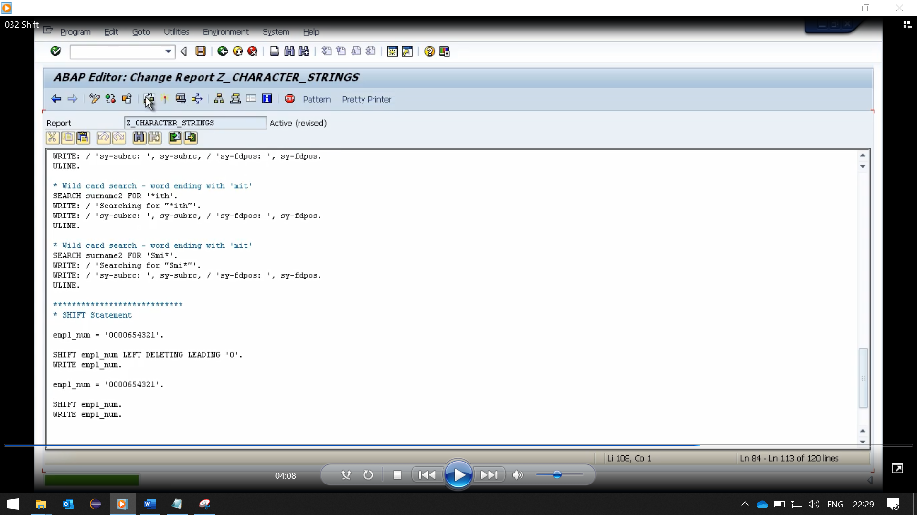

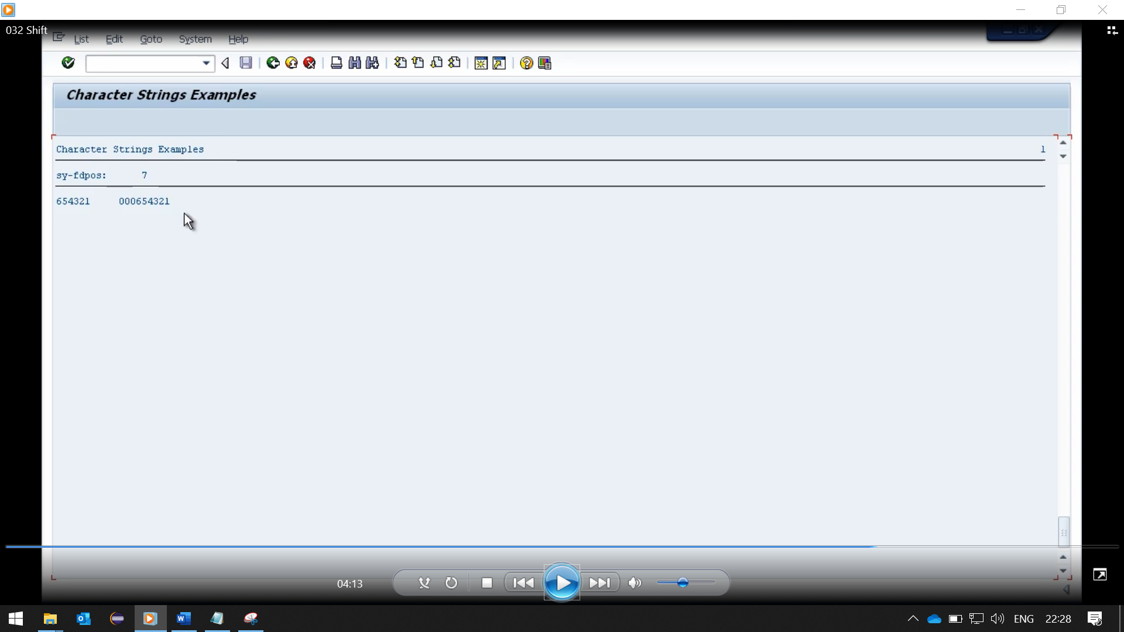

I'll just do another few examples. This one, I'll show the shift statement in its simplest form. Now what we will see here, because we haven't specified anything after our variable name it will use the default value of moving from right to left. And the default number of spaces is 1. So, it will move to the left one character.

So, on the test, you can see we've only got three zeros in the output, and it's moved all the contents to the left, and left us with one space at the end.

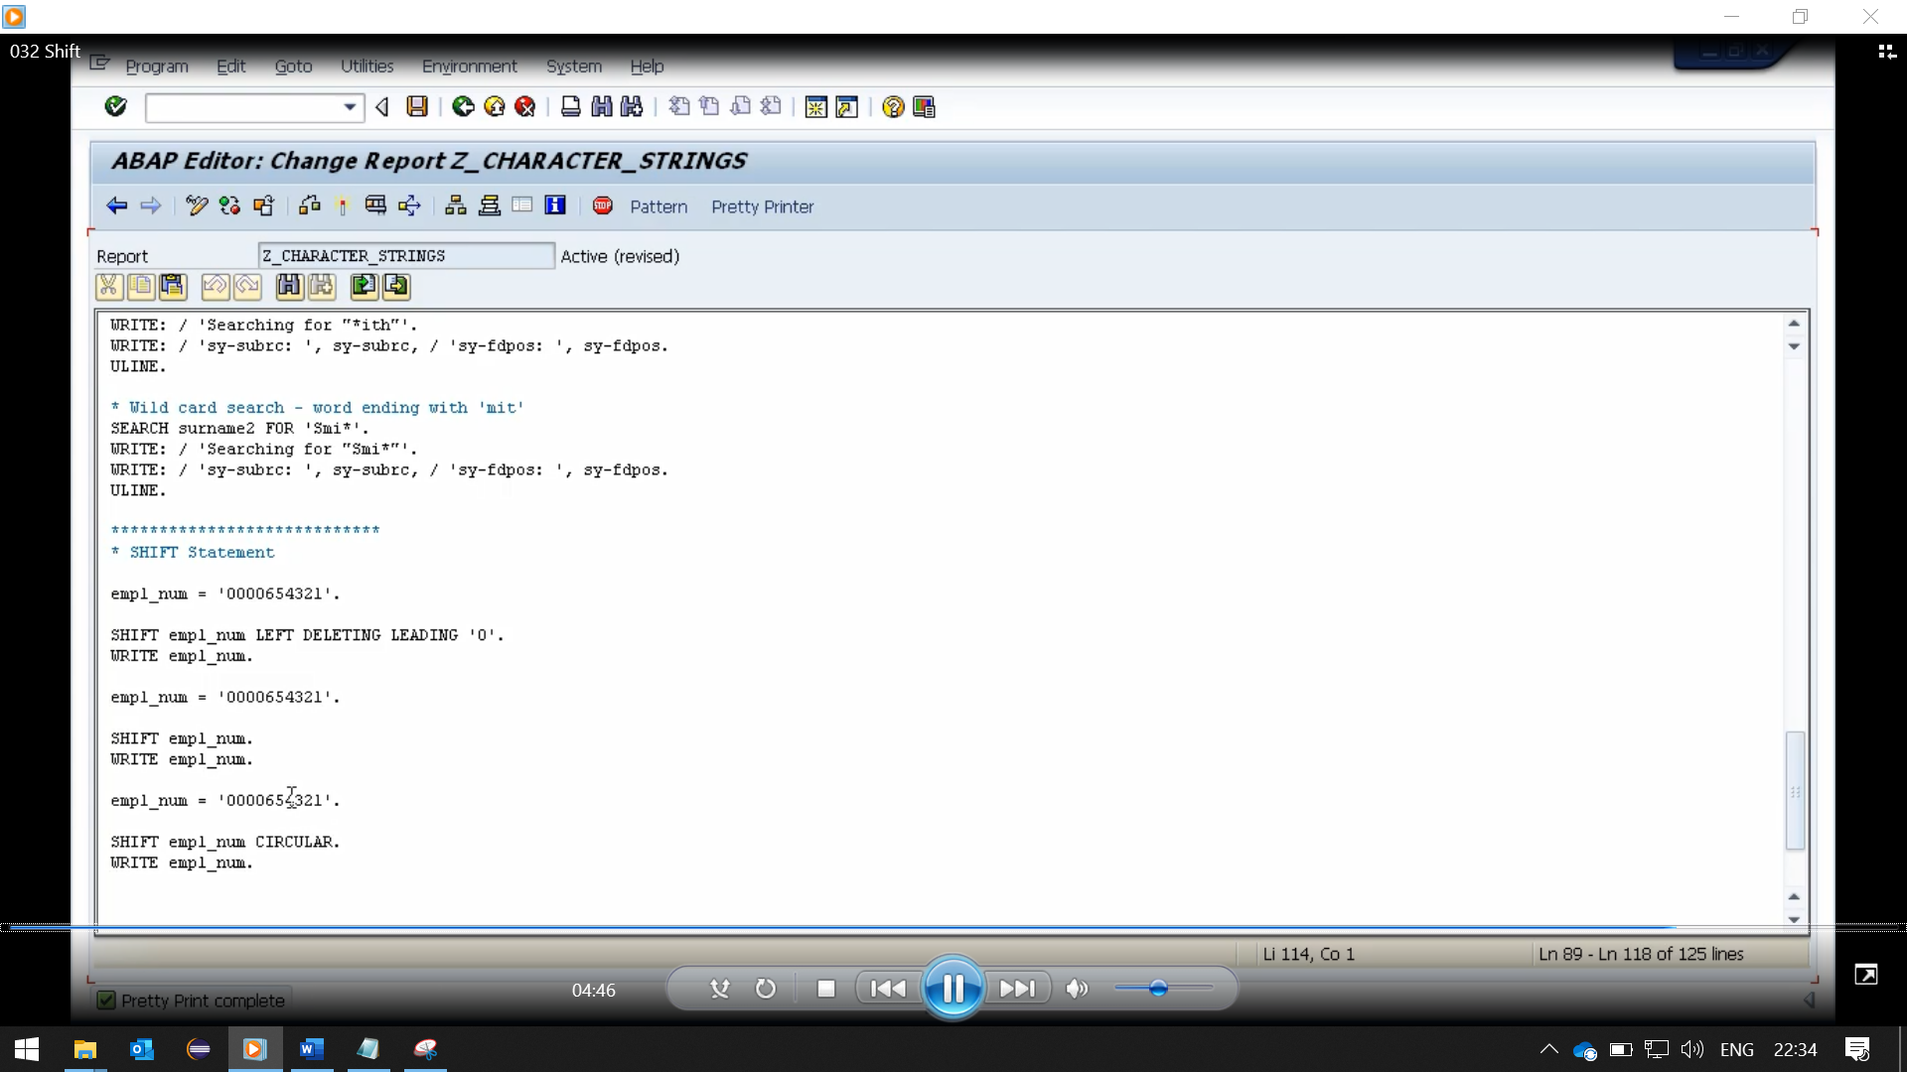

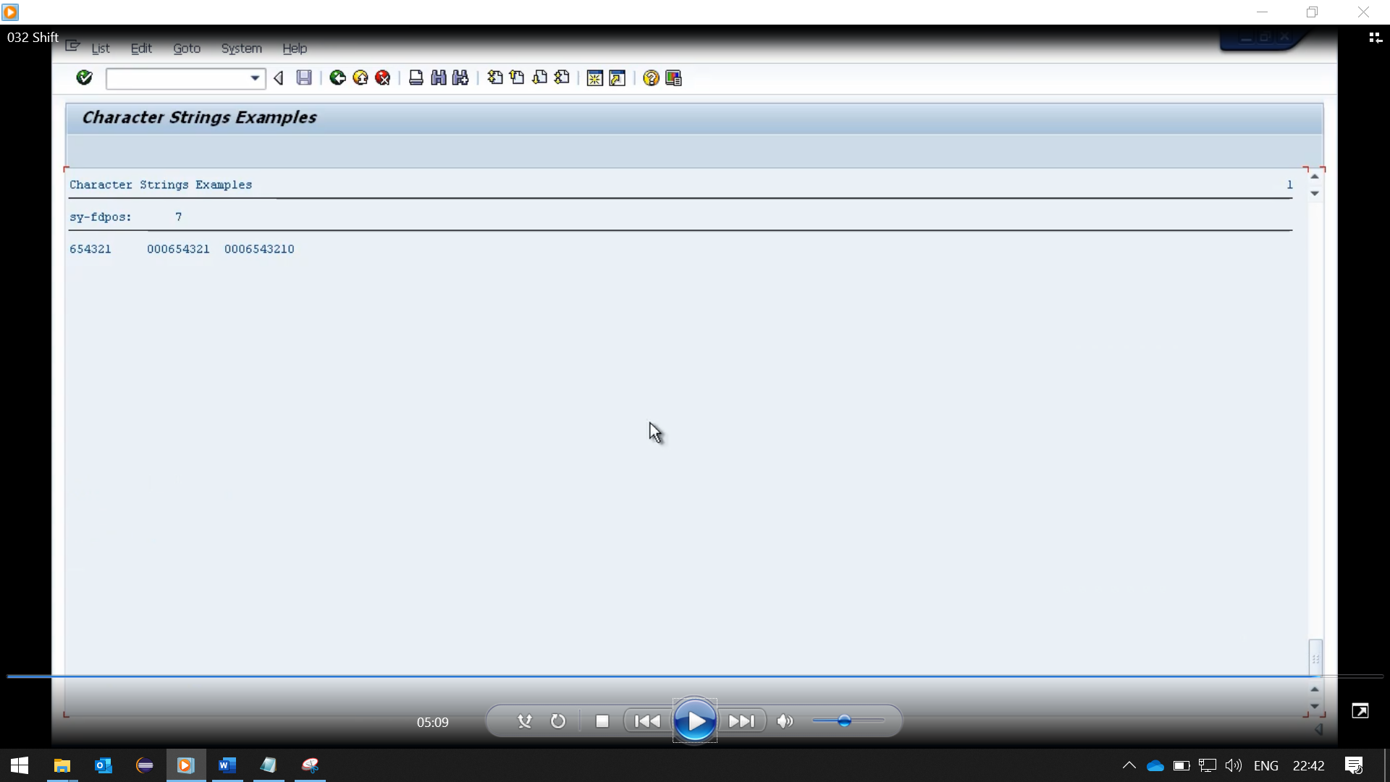

The next example, we will use the addition circular. And what this does if we leave it with the default values, it'll move everything to the left one character. But the character that is pushed out will be reinserted at the other end of the string. So, we should see 0006543210 in the result. And here you can see exactly that. That the 000, and then the leading 0 that is being pushed out, is being inserted in the far-right column.